Project Design Phase-II
Data Flow Diagram & User Stories

Date | 06/02/2026
Team ID | LTVIP2026TMIDS81483
Project Name | Prosperity Prognosticator: Machine Learning for Startup Success Prediction
Maximum Marks | 4 Marks

Data Flow Diagrams:
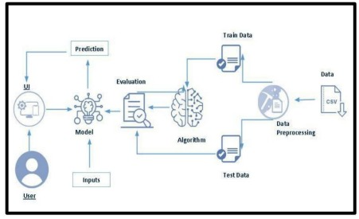
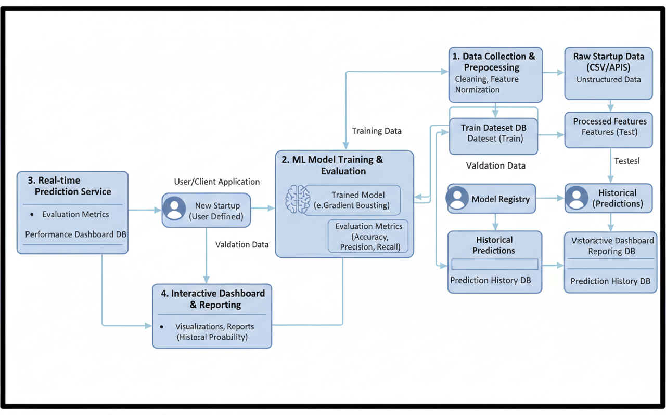
A Data Flow Diagram (DFD) is a traditional visual representation of the information flows within a system. A neat and clear DFD can depict the right amount of the system requirement graphically. It shows how data enters and leaves the system, what changes the information, and where data is stored.

User Stories

Use the below template to list all the user stories for the product.
User Type | Functional Requirement (Epic) | User Story Number | User Story / Task | Acceptance criteria | Priority | Release
Customer (Mobile user) | Registration | USN-1 | As a user, I can register for the application by entering my email, password, and confirming my password. | I can access my account / dashboard | High | Sprint-1
Customer (Mobile user) | Registration | USN-2 | As a user, I will receive confirmation email once I have registered for the application | I can receive confirmation email & click confirm | High | Sprint-1
Customer (Mobile user) | Registration | USN-3 | As a user, I can register for the application through Facebook | I can register & access the dashboard with Facebook Login | Low | Sprint-2
Customer (Mobile user) | Registration | USN-4 | As a user, I can register for the application through Gmail | User can login using Gmail OAuth. | Medium | Sprint-1
Customer (Mobile user) | Login | USN-5 | As a user, I can log into the application by entering email & password | User successfully accesses dashboard. | High | Sprint-1
Customer (Mobile user) | Dashboard | USN-6 | As a user, I can view startup success prediction result. | Data is validated and submitted successfully.
Customer (Web user) | Prediction | USN-7 | As a user, I can view startup success prediction result. | System displays Success/Fail with confidence score. | High | Sprint-2
Customer Care Executive | Report | USN-8 | As a user, I can download prediction report. | PDF/CSV report is generated successfully. | Medium | Sprint-3
Administrator | Dataset Management | USN-9 | As an admin, I can upload and update training dataset. | Dataset updated successfully in system. | High | Sprint-1
Administrator | Model Management | USN-10 | As an admin, I can retrain ML model with new data. | Model accuracy improves and new model saved. | Medium | Sprint-1
Administrator | Monitoring | USN-11 | As an admin, I can view model performance metrics. | Dashboard shows accuracy, ROC, and F1-score. | High | Sprint-1

